**Q1. Capture and analyze ARP packets using Wireshark. Inspect the ARP request and reply frames, and discuss the role of the sender's IP and MAC address in these packets.**

**Simple network setup:**

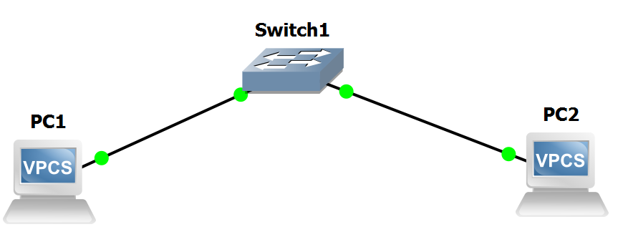

**Pinging PC1 and PC2:**

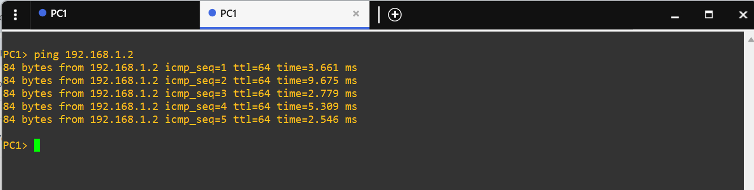

**Capturing packets using wireshark:**

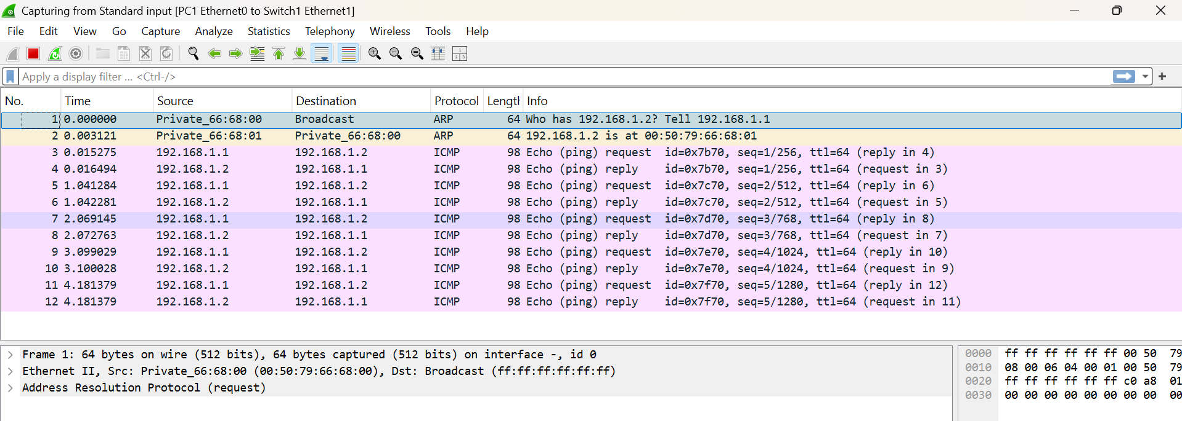

**Applying arp filters:**

